**Number of subarrays with sum zero**

Problem

Given an array a[] of size n. Our task is count the number of subarrays with sum zero.

Example



Subarrays with sum zero are:

, , , 

Number of subarrays with sum equal to zero are 6.

Brute force approach

1. Iterate over all the subarrays using nested loops, simultaneously calculate *sum* and maintain a variable *cnt.* Increment count whenever sum adds up to zero.

Time Complexity: O(n2)

Optimized approach

1. Compute prefix sum array. For the above example, It will look like



1. Main idea: For an array of prefix sum if a value repeats in prefix sum array at indices *i* and *j*, it denotes sum of elements from indices *i+1* till *j* is zero.

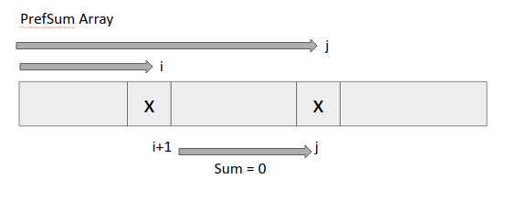

So, we have to find the number of ways in which we can choose two same valued elements in the PrefSum array. (Special case for PrefSum[i]=0, as they add upto zero from starting index)

1. Declare a map (say freq) denoting frequency of elements in the prefix sum array.

*map<int,int> freq;*

1. Iterate over the PrefSum array and just do

*freq[PrefSum[i]]++;*

1. After our freq map is created, then apply permutation and combination formula to choose 2 elements from the group of m identical items. (mC2) for each key.

Code

